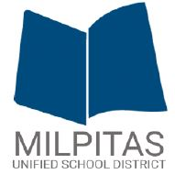 | CITY OF MILPITAS  MILPITAS UNIFIED SCHOOL DISTRICT  City-School Collaborative Subcommittee Agenda  September 13, 2019, 4 p.m.  Milpitas Unified School District, Board Room  1331 E. Calaveras Blvd., Milpitas CA | 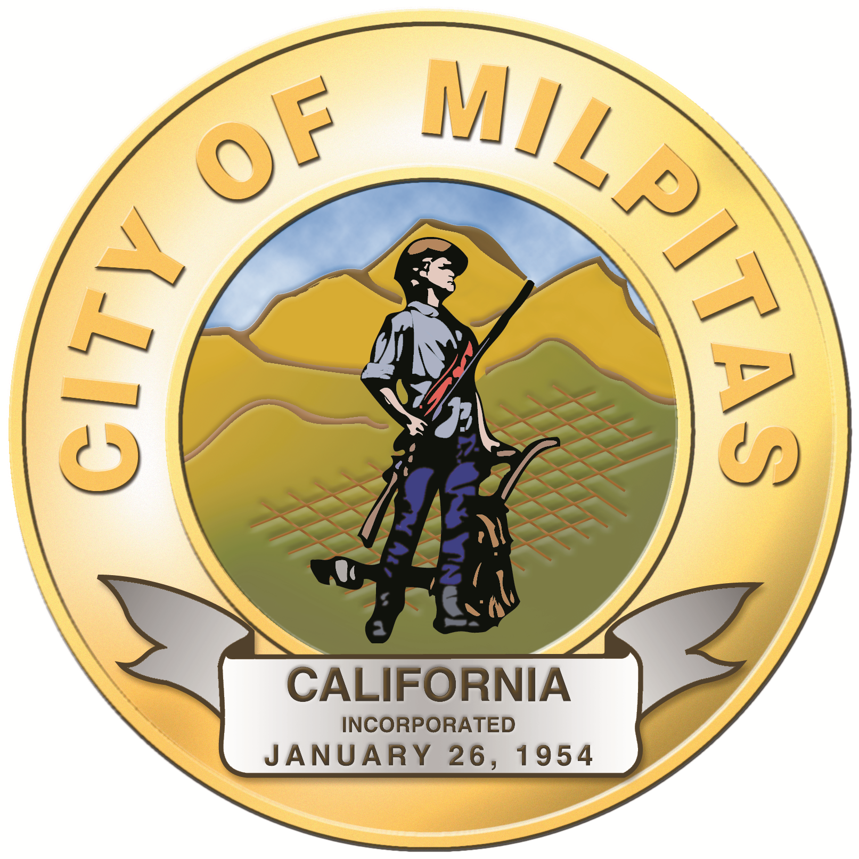

AGENDA

- CALL TO ORDER
- FLAG SALUTE

- PUBLIC FORUM

- APPROVAL OF AGENDA

- DISCUSSION ITEMS

- Safety Talk Discussion
    - School safety
      - Security Cameras First Eyes by VIAAS (Joint cost sharing)
      - SROs
      - Campus Supervisors
      - MUSD Intruder Safety Plans
    - Vaping
2) Milpitas Pathways for all
3) Student Civic Engagement
a) What is the Youth Commission Charter, Vision and Mission?

4) Bond Measure Projects Update

5) Child & Family Homelessness Relief (City Housing Subcommittee)

6) Marketing/Communications (city)

- ANNOUNCEMENTS
- DATE OF NEXT MEETING: TBD – City Hall

- ADJOURNMENT

